NAME: KAVITAPU SWARNA VARSHINI
REG.NO: 192324081
DATE: 14-07-2026

Write a python program for Breadth-First Search (BFS)
AIM: To write a Python program to implement the Breadth-First Search (BFS) algorithm for graph traversal.
ALGORITHM:
- Represent the graph using an adjacency list.
- Start the traversal from the given source node.
- Use a queue to visit nodes level by level.
- Mark each visited node to avoid revisiting it.
- Continue until all reachable nodes are visited and display the traversal order.
CODE:
from collections import deque
graph = {
'A': ['B', 'C'],
'B': ['D', 'E'],
'C': ['F'],
'D': [],
'E': ['F'],
'F': []
}
visited = set()
queue = deque(['A'])
while queue:
node = queue.popleft()
if node not in visited:
print(node, end=" ")
visited.add(node)
queue.extend(graph[node])
OUTPUT:
A B C D E F
IMAGE:
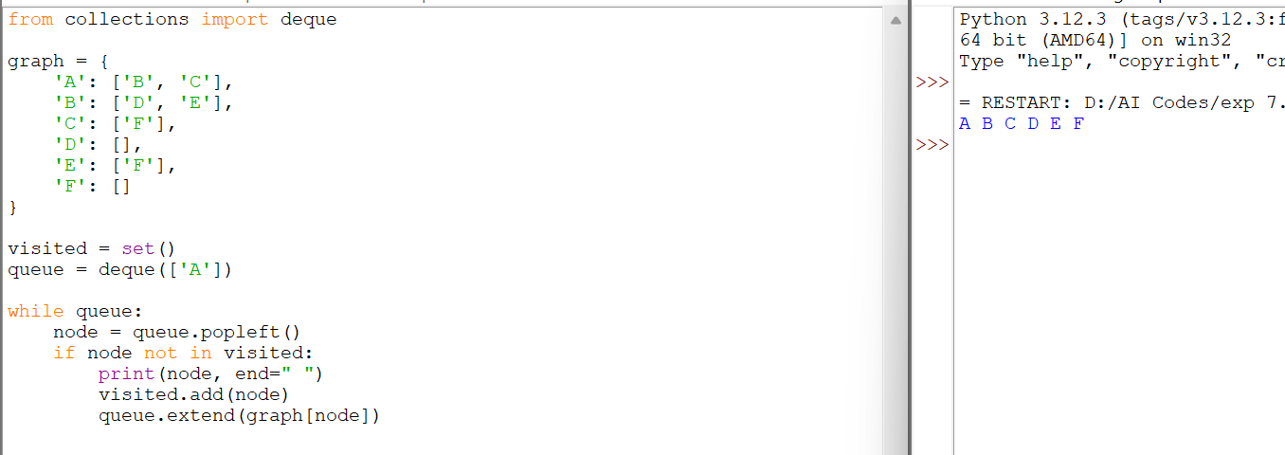

RESULT:
The Python program successfully implemented the Breadth-First Search (BFS) algorithm and traversed the graph in level-by-level order using a queue.

